

EVENT DESCRIPTION:

Our first General Meeting focused itself to welcoming new members from our virtual club rush and to update the returning members as well as our new plans to handle service events and the club activities in general. The turn out was great as we received around 55 members in the zoom, most being new members. It was exciting holding most of the boards first general meeting and getting more people to help the community through the club. We explained Key Club and the current district and home events that are planned, and we hopefully will see an increase in member activity.

* Diego Sahagun

Visual #1

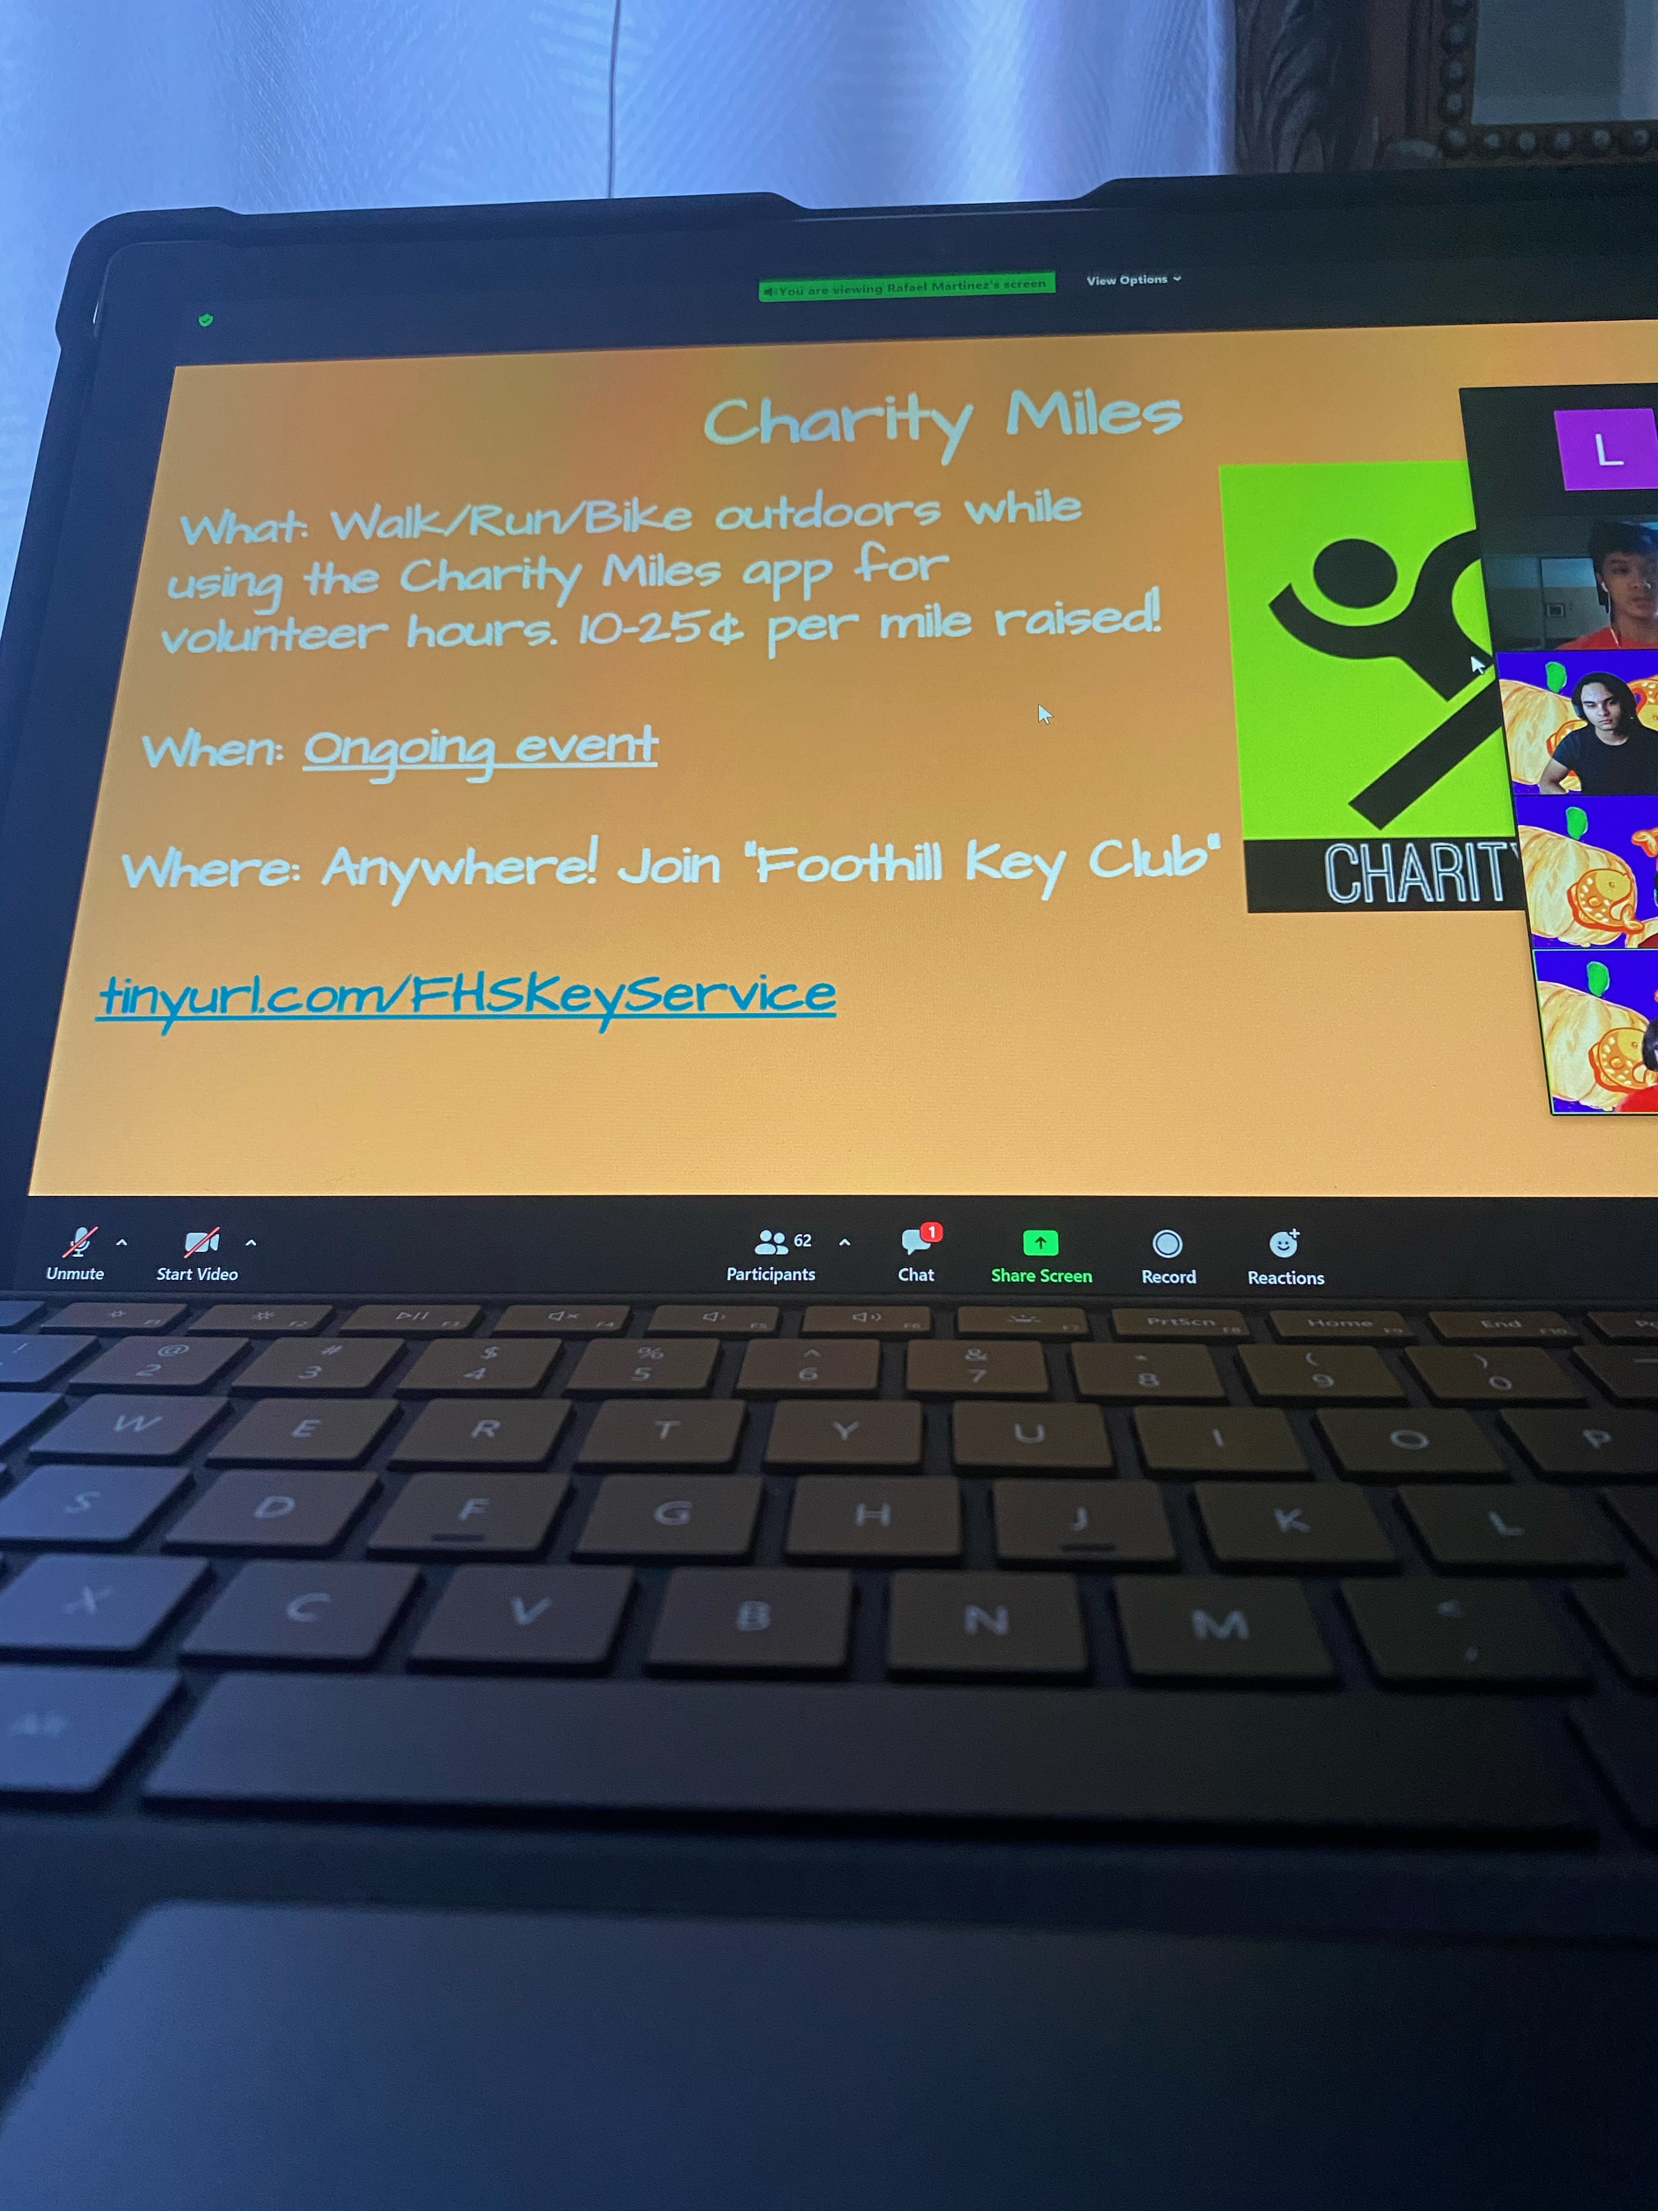

**Foothill| DIVISION 4 EAST | 2020**

**First General Meeting**